# DATA ANALYTICS ASSIGNMENT 3

SRILATHA MADDASANI

20NN1A05F0

IV B.TECH (CSE)

VIGNAN’S NIRULA INSTITUTE OF TECHNOLOGY AND SCIENCE FOR WOMEN (VNITSW)

**DATASET USED:**



Sample - Superstore

(1).xls

* **Define at least two sets based on specific criteria from your dataset (e.g., high value customers, top-performing products).**
* **Experiment with combining sets using UNION, INTERSECT, and MINUS operations.**
* **Create 2 Calculated Fields using any Aggregate Functions**
* **Create any 3 Visualization using Quick Table Calculations**

# HIGH VALUE CUSTOMERS BY SALES

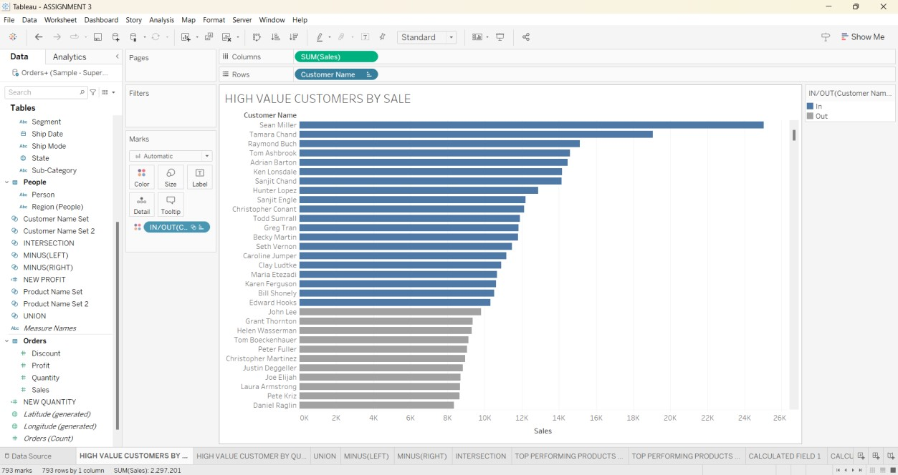

# HIGH VALUE CUSTOMERS BY QUANTITY

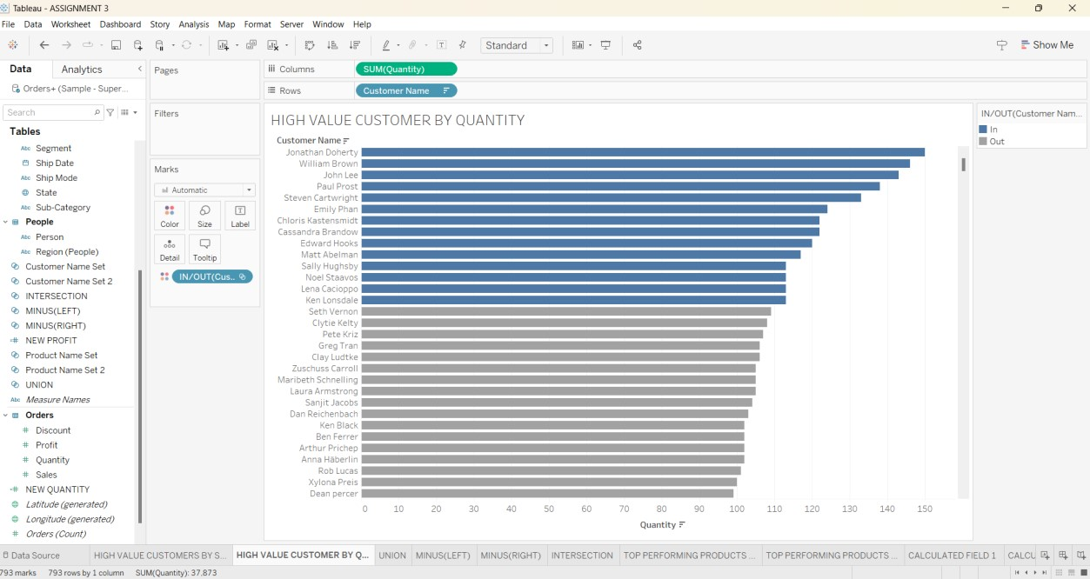

# TOP PERFORMING PRODUCTS BY SALES

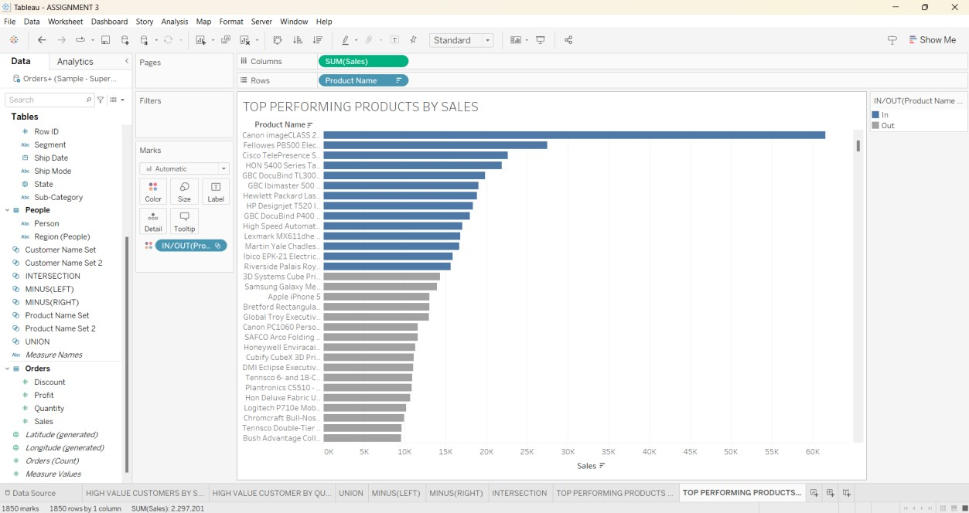

# TOP PERFORMING PRODUCTS BY QUANTITY

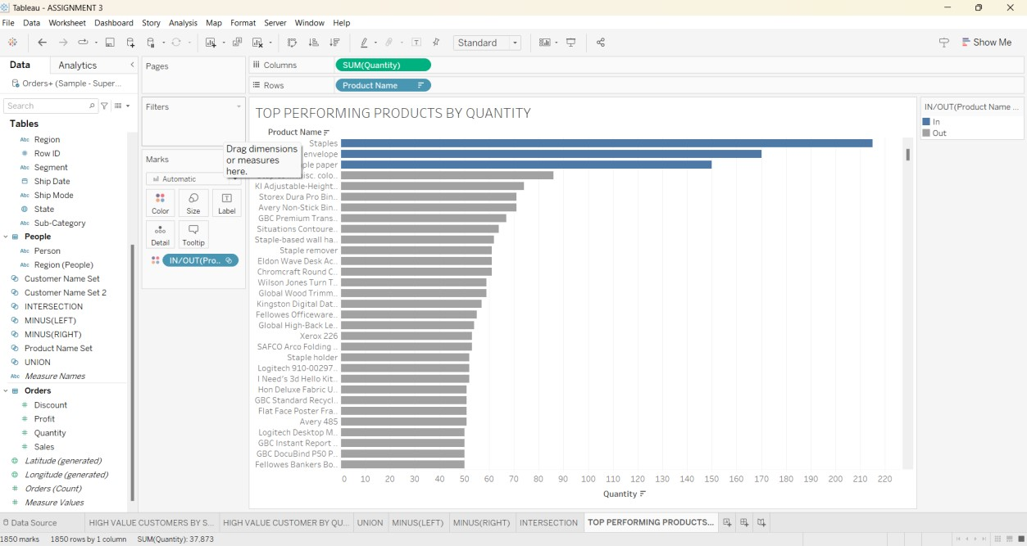

# UNION OF TWO SETS

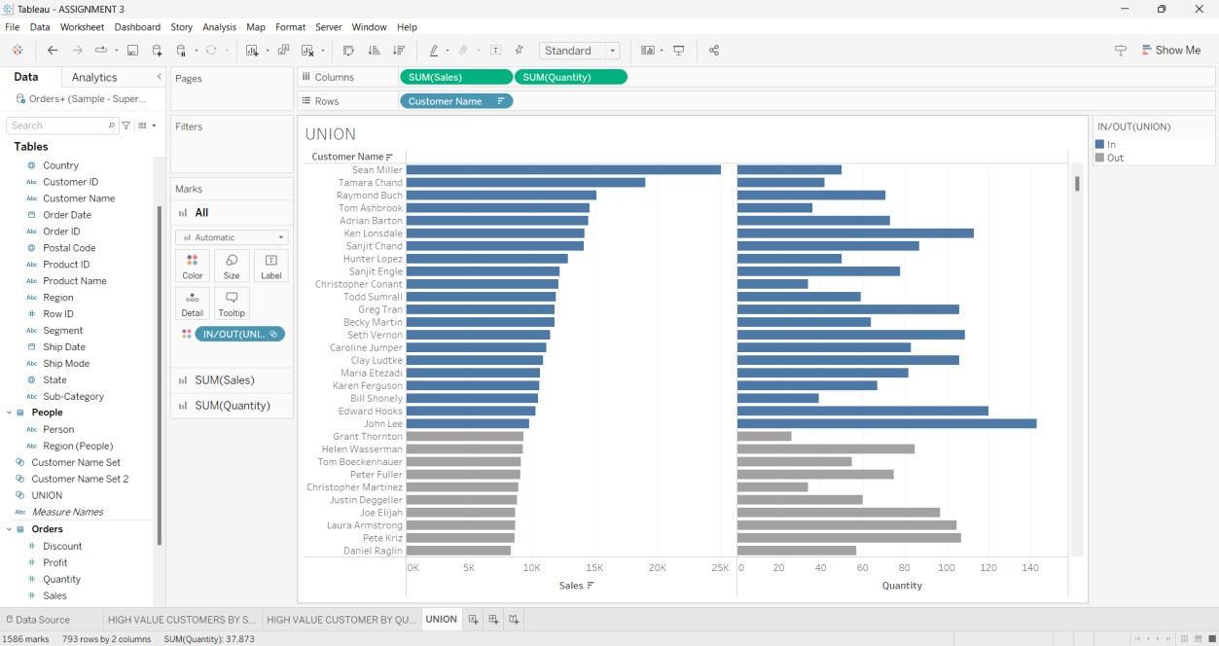

# MINUS (LEFT JOIN) OF TWO SETS

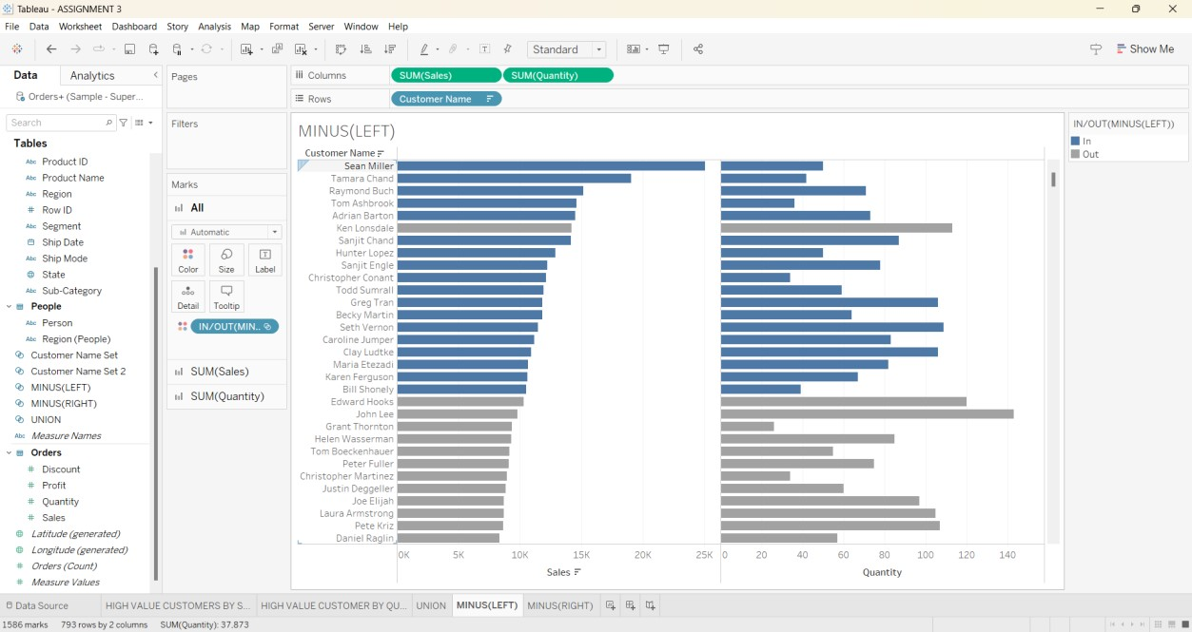

# MINUS (RIGHT JOIN) OF TWO SETS

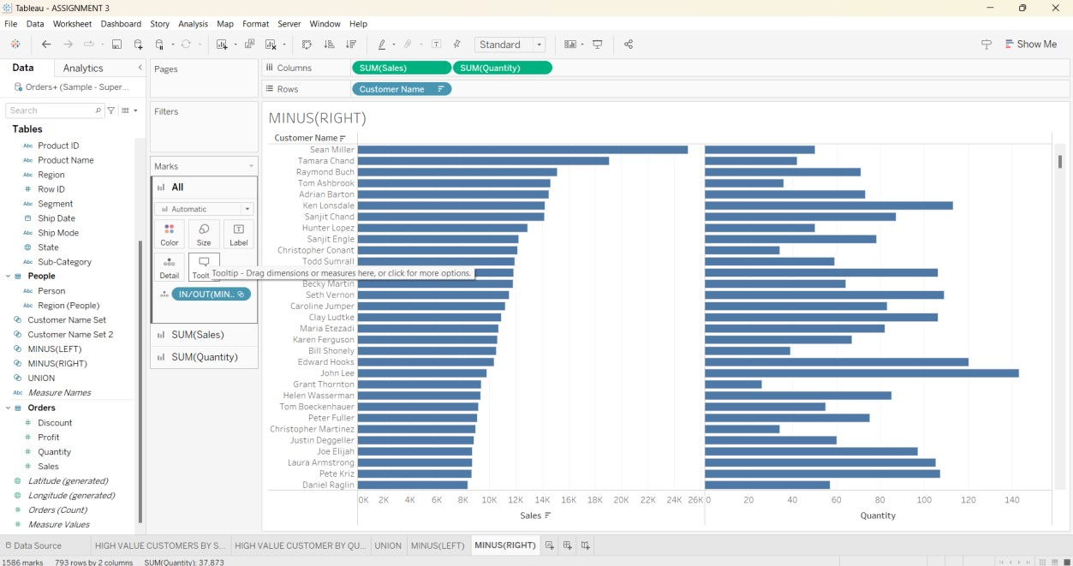

# INTERSECTION OF TWO SETS

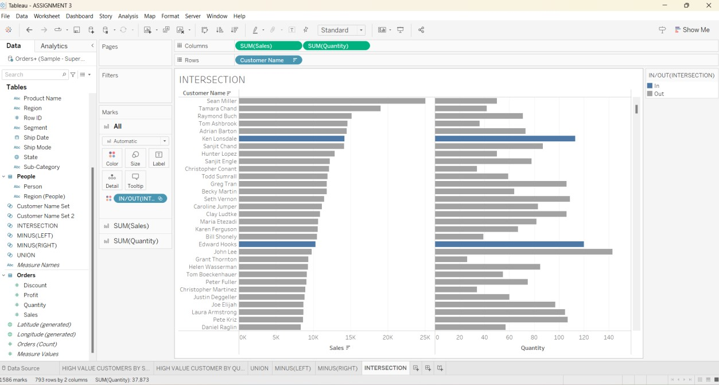

# CALCULATED FIELD 1

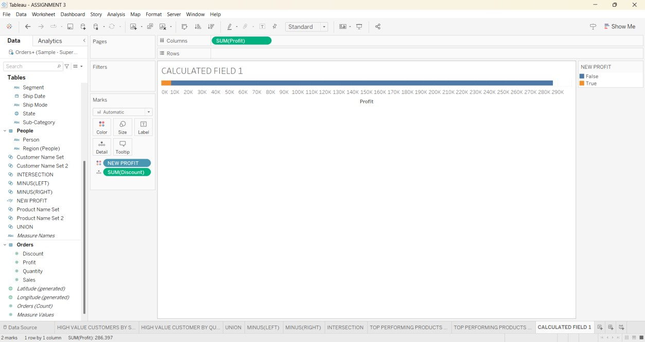

# CALCULATED FIELD 2

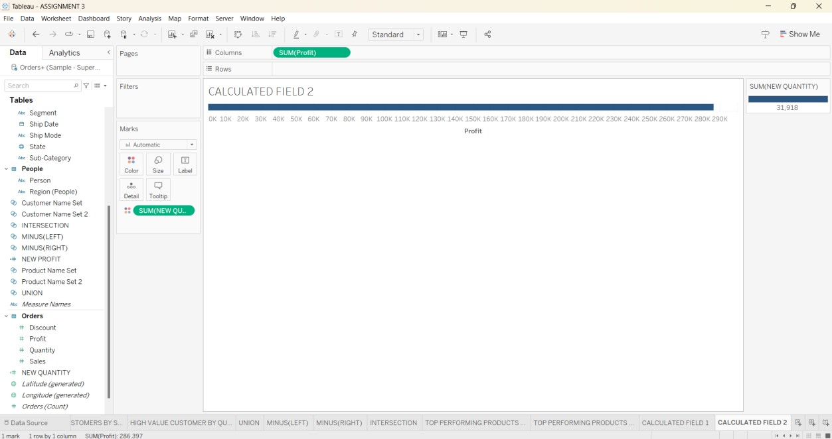

# QUICK TABLE CALCULATIONS PERCENTILE

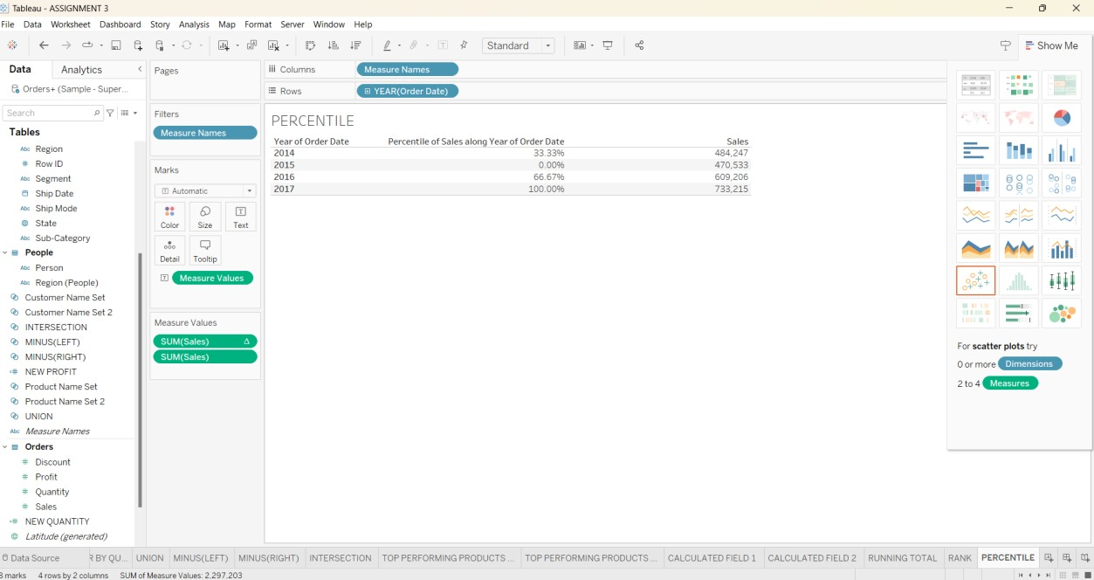

# RANK

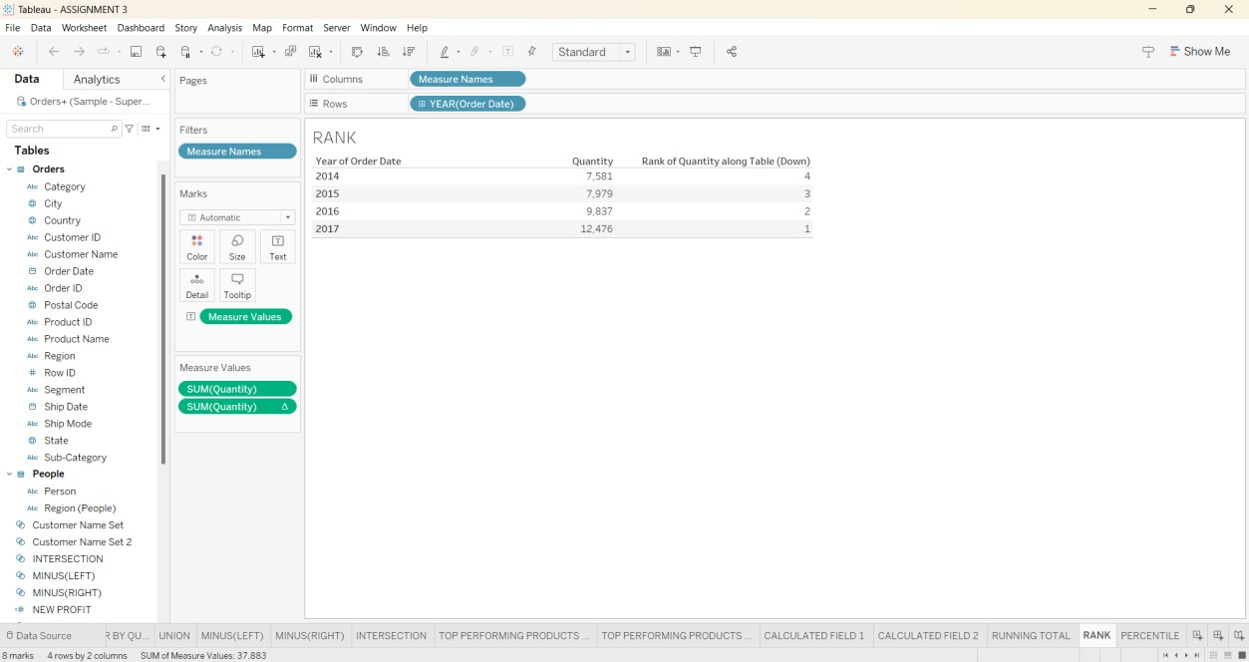

# RUNNING TOTAL

